Lunch List Assignment Ten
Create a new activity for the details form. The main screen will only contain the list. The list should be created with a List Fragment. Add an Add button to the menu. When an item is clicked on the list pass the Id to the details form using the extra data structure. When the add button is pressed start the details form and do not pass and Id. In the details form, get save to add a new one and updated an existing one if editing an existing restaurant.
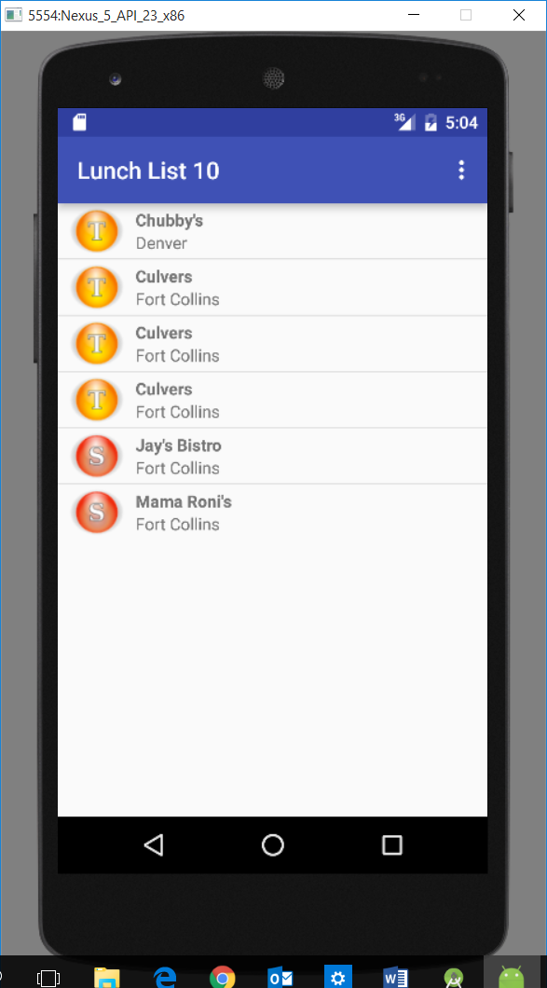

Add button:
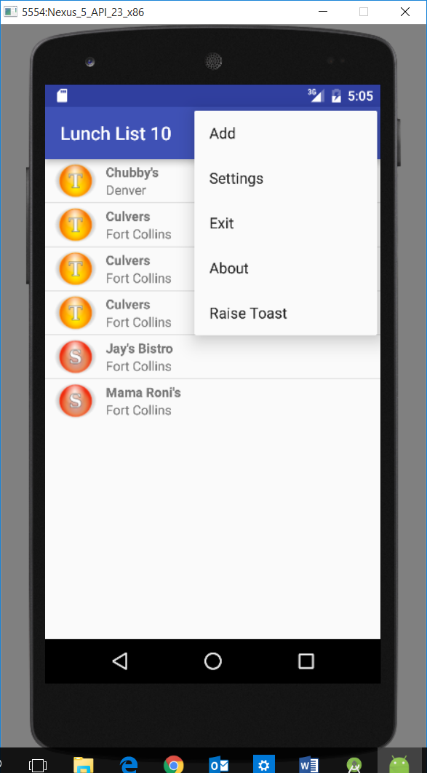

Details form:
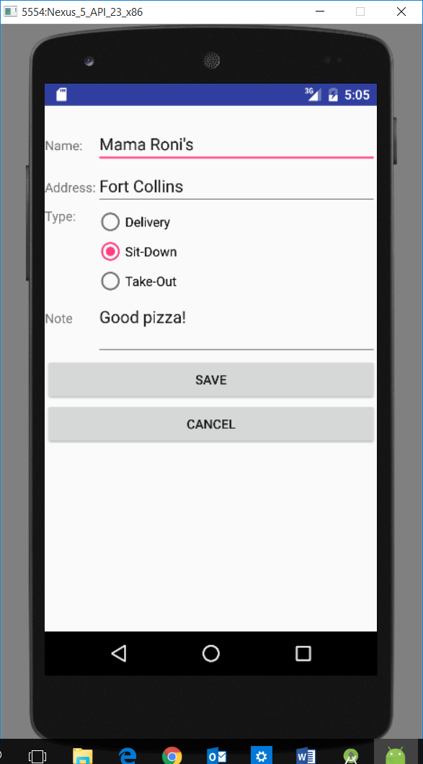
Your grade will be based upon the following:
Criteria | Points
Project and zip file submitted to Desire2Learn are named correctly. Format to follow is yourNameLunchListAssignmentThree. | 5
Compiles | 5
List View is in List Fragment | 5
Add on menu | 5
DetailsForm Created (class & UI) | 5
Database Helper class updated with required methods | 5
Edit existing works | 5
Save new works | 5
Total | 40

